Hot Wings: The Impact of Large Appendages on the Heat Loss Potential and Migratory Decision-Making of Humpback Whales
William T. Gough$​^{1}$, Martin van Aswegen$​^{1}$, Lewis Evans$​^{1}$, Andy Szabo$​^{1,2}$, Jens J. Currie$​^{1,3}$ Andreas Fahlman$​^{4,5}$, Fredrik Christiansen$​^{6}$, Augusta Hollers$​^{1}$, Frank E. Fish$​^{7}$, Kristi West$​^{8}$, Jana Phipps$​^{8}$, Nicholas Hofmann$​^{8}$, Lars Bejder$​^{1}$

Affiliations
- Marine Mammal Research Program, Hawaiʻi Institute of Marine Biology, University of Hawaiʻi at Mānoa, Kaneohe, HI 96744 USA
- Alaska Whale Foundation, PO Box 1927, Petersburg, AK 99833 USA
- Pacific Whale Foundation, 300 Maʻalaea Road, Suite 211, Wailuku, HI 96793 USA
- Fundacion Oceanografic, Carrer d’Eduardo Primo Yúfera, 1B, 46013, Valencia, Spain
- Global Diving Research SL, Sanlucar de Barrmeda, 11540, Spain
- Department of Ecoscience, Aarhus University, 4000 Roskilde, Denmark
- West Chester University, 700 S High St, West Chester, PA 19383 USA
- Health and Stranding Lab, College of Tropical Agriculture and Human Resources, University of Hawaiʻi at Mānoa, Honolulu, HI 96822 USA
Correspondence: wgough@hawaii.edu

Abstract
Marine mammals regulate metabolic heat and maintain core body temperature through the interplay of an insulative blubber layer and blood flow through uninsulated thermal windows (e.g., flippers, fins, flukes). Compared to other cetaceans, humpback whales (Megaptera novaeangliae) have uniquely large pectoral flippers and tail flukes relative to body size, which likely function as potent thermoregulatory windows. We estimated the heat loss potential for humpback whales (n = $5929$ individuals) spanning a wide range of body sizes ($3.75$-$14.8$ m) and demographic classes in both warm (Hawaiʻi) and cold water (Southeast Alaska) environments. Mean daily heat loss was higher in Hawaiʻi with thermal windows “open” ($5803$±$1432$ MJ day⁻¹) than in Southeast Alaska with thermal windows “closed” ($3158$±$994$ MJ day⁻¹), representing the upper and lower bounds of heat dissipation and conservation, respectively. Adults in Hawaiʻi were capable of producing metabolic heat equal to or exceeding their maximal heat loss potential. Calves born in Southeast Alaska were predicted to require higher minimum metabolic rates to offset heat loss compared to those born in Hawaiʻi. Interpreting heat loss as a distinct energetic cost as opposed to a metabolic byproduct, Southeast Alaska calves would face an additional heat loss burden of $6938$ MJ (equivalent to ~$9.4$-$17.6$% of somatic growth costs during the first 90 days of life), reducing energy available for other critical life processes. These results demonstrate that the large appendages of humpback whales provide a powerful mechanism for regulating heat loss, allowing individuals to avoid both hyperthermia and hypothermia across contrasting thermal environments.

Introduction
Maintaining a favorable balance between energetic gain and expenditure is critical for the continuation of life. For animals, energetic intake comes from a singular source (foraging), but energetic costs are often varied and include complex behavioral and physiological processes such as locomotion (for motile species) (Alexander, 2005; Schmidt-Nielsen, 1972), prey capture (Bolnick and Ferry-Graham, 2002; Griffiths, 1980), digestion (Armstrong and Blaxter, 1956), somatic growth (Christiansen et al., 2022; Millward et al., 1976; van Aswegen et al., 2025c), reproduction (Bell, 1980; Remick, 1992), thermoregulation (Scholander et al., 1950), and basal metabolism (He et al., 2023; Kleiber, 1975; Spaargaren, 1994). For species that can be housed under human care, these costs can oftentimes be quantified holistically or separated out into their component processes (Allen et al., 2022; Fahlman et al., 2025; Lindström et al., 1999; Williams and Davis, 2024). For larger or cryptic species that cannot be housed under human care, or for situations where species cannot be reliably observed without significant changes to behavior, energetic estimates are often modeled through a patchwork of quantifiable parameters and up-to-date approximations from more tractable species or historical records (Boyles and Brack, 2009; Gough et al., 2022; Pirotta et al., 2018).
The infraorder Cetacea includes many large-bodied, highly mobile species that cannot be ethically or logistically maintained in human care. Field experiments on large, free-swimming cetaceans require ideal conditions, large swaths of open ocean, and cutting-edge technology (e.g., biologging tags, unmanned aerial systems [UAS] drones, acoustic monitors) to interpret changes in behavior (Castellote et al., 2012; Curé et al., 2013; Curé et al., 2015; Southall et al., 2016). These constraints have made large cetaceans strong candidates for computational modeling, both to generate energetic baselines (Christiansen et al., 2023; Fahlman et al., 2025; Goldbogen et al., 2019a; Gough et al., 2022; Gough et al., 2025) and to explore the potential physiological consequences and energetic costs associated with disturbance (Christiansen et al., 2025; Czapanskiy et al., 2021; Hin et al., 2019; Pirotta et al., 2018).
Long-distance migrations between cold foraging areas and warm breeding habitats add significant complexity to energetic modeling of large whales. Understanding the annual energetic cycle of these species requires empirical data or accurate estimations of various costs for both sides of the migratory route. Given the substantial differences in water temperature between the two locations (as much as ~30°C), thermoregulation is likely among the most energetically costly processes affected by migration, requiring a suite of adaptations to either conserve or dissipate heat in response to environmental conditions (Favilla et al., 2024). Researchers have posited multiple behavioral reasons for the migratory life history of large whales, including predator avoidance in the early stages of life, enhanced parasite removal, seasonality of resources, or the possibility of a more favorable thermal environment during early development (Clapham, 2001; Corkeron and Connor, 1999; Pitman et al., 2020). This latter hypothesis treats thermoregulation as a distinct energetic cost. However, recent studies (Christiansen et al., 2026; Sumich, 2021) have challenged this interpretation, suggesting instead that heat loss is simply a byproduct of metabolism. These studies have found the heat loss of newborn calves to be lower than their estimated $FMR$, implying that thermoregulation is unlikely to drive migration provided the calves can adequately dissipate excess metabolic heat (Christiansen et al., 2026; Sumich, 2021).
The majority of cetacean heat loss is thought to be modulated through regional heterothermy in the extremities (i.e., flippers, tail flukes, and dorsal fin), with a counter-current heat exchange system that either restricts or facilitates the movement of warm blood near to the skin’s surface (Scholander and Schevill, 1955). This system consists of rosettes of rings of veins surrounding a central artery that permits heat exchange to route warm blood back to the body. When a large heat load must be dissipated, a rise in blood pressure increases the diameter of the central artery collapsing the surrounding veins and distributing blood to superficial veins beneath the skin. Body and appendage sizes should, therefore, have a significant impact on thermoregulation. Bergmann’s rule suggests that larger animals with lower surface-to-volume ratios will inhabit colder environments at higher latitudes, while Allen’s rule suggests that species living in colder environments will have smaller appendages to decrease excess heat loss (Ray, 1960; van Aswegen et al., 2019). Among the large whales, the humpback whale (Megaptera novaeangliae) exist at an intersection of these two rules, having large body sizes (~30,000 kg; ~12-14 m in length; van Aswegen et al., 2025c), but also disproportionately large flippers (~30% of body length) (Fish and Battle, 1995; Kahane‐Rapport and Goldbogen, 2018). It is also one of the few large whale species that migrates all the way from near-freezing polar waters to warm tropical waters and back, thereby experiencing an exceptionally wide range of thermal environments.
Models of thermoregulatory costs in large whales have traditionally focused on the heat loss potential of the body, with thermal windows represented as areas of minimal heat loss that remain “closed” (Christiansen et al., 2026; Glarou et al., 2025a; Sumich, 2021). This approach provides a lower bound for heat loss but does not account for the ability of these thermal windows to dissipate excess heat and maintain thermoneutrality. Conversely, estimating the maximal heat loss from these thermal windows establishes an upper limit of heat loss and enables the estimation of the maximal sustainable metabolic rate. For species with large thermal windows, such as humpback whales, this increased surface area for heat dissipation may support higher metabolic rates, and therefore higher activity levels, compared to similarly sized species with smaller appendages.
In this study, we combined morphometric data from UAS (unoccupied aerial systems i.e., drones) with behavioral data from biologging tags (e.g., ventilation rates) and anatomical measurements from stranded animals (e.g., body and appendage blubber thicknesses) into a model of whole-body heat loss potential for humpback whale adults and calves in both a warm-water breeding ground (Hawai‘i) and a cold-water foraging ground (Southeastern Alaska) (Figure 1A). These estimates incorporate context-dependent heat loss through the appendages (Figure 1B-C). Our results indicate that adults possess adequate blubber insulation to tolerate cold summer feeding temperatures (2–5 °C), but may need to reduce activity on warm winter breeding grounds to prevent overheating, even with enhanced heat-dissipating appendages. We also found that the small average body size of newborn calves would necessitate a higher minimum metabolic rate in cold Alaskan waters, but not in warmer Hawaiian waters. This increased minimum metabolic rate required by calves in Southeast Alaska would amount to an additional total heat loss burden of $6938$ MJ, if we assume that heat loss is a distinct energetic cost to the animal. This would be equivalent to ~$9.43$-$17.6$% of their estimated growth costs during the first 90 days of life (van Aswegen et al., 2025c).

Methods

Morphometric Variables From UAS-Photogrammetry
For the majority of our analyses, we used a dataset of morphometrics (n = $5929$ individuals) collected by UAS-photogrammetry on humpback whales between 2018 and 2025 across Hawaiian (breeding ground; n = $3701$) and Southeast Alaskan (foraging ground; n = $2228$) waters. Additional details on the UAS protocols and data collection methodology pertaining to this dataset have been provided by van Aswegen et al. (2025b; 2025a; 2025c).
Morphometric measurements for each animal included the total body length from the anterior point of the rostrum to the tail notch ($TL$; in m) and 19 distinct width measurements taken at 5% intervals along the length of the animal. From the combination of these length and width measurements, we estimated the body volume ($BV$; in m³) following the approach of Christiansen et al. (2019), applying body height-width ratios measured in van Aswegen et al. (2025c). The body condition of each animal was estimated using residuals calculated from the log-log linear relationship between BV and TL, fitted separately for adult female, male, and unknown-sex whales (van Aswegen et al. 2025c). We estimated total body mass ($M_{\text{body}}$; in kg) following Christiansen et al. (2022), by partitioning the body volume of an animal into tissue types that scale with TL - muscle, bone, viscera - and blubber volume, which varies with body condition. Body surface area ($S_{\text{body}}$; in m²) was calculated using the approach of Glarou et al. (2025a), using our estimates of $TL$, body width, and body height. Calf age was estimated following van Aswegen et al (2025c), by modeling birth size and postnatal growth rates as functions of maternal length. Approximate birth dates were inferred from the predicted body volume at birth and daily growth rates derived from repeated measurements or from the relationship between maternal length and calf body volume growth rates. Figure S1 provides a visualization for a subset of relevant morphometric measurements.
We used a subset of UAS images to determine the surface area of the pectoral flippers ($S_{\text{flippers}}$; in m²) and tail flukes ($S_{\text{flukes}}$; in m²). In all images, animals were at the surface with their flippers and flukes extended and flat. We used ImageJ v1.54g (Schindelin et al., 2012) to scale each image to the known total body length of the animal ($TL$), then outline each extremity to determine the dorsal area ($S_{flippers}$ and $S_{flukes}$; in m²). The left and right sides of each pair of extremities were measured separately, then averaged together to account for measurement error. To determine the overall area of each pair of extremities, the “single side” values for $S_{flippers}$ and $S_{flukes}$ were quadrupled. For each individual in our subset of UAS images, we regressed relevant morphometric values ($S_{flippers}$ and $S_{flukes}$) against $TL$ (Figure S2) and used those predictive models to estimate the extremity areas for each individual in our broader dataset.

Body and Appendage Blubber Thickness
We estimated the body blubber thickness ($BT_{\text{body}}$, m) as a same-thickness sheet surrounding the entire body (without appendages) using a regression equation taken from Glarou et al. (2025a):
$$BT_{\text{body}}=TL*\left(0.0119345-\left(0.0003168*TL\right)\right) \left(1\right)$$
To determine the blubber thickness of the appendages ($BT_{\text{appendage}}$), we obtained flippers and/or flukes from stranded individuals representing multiple species, including the pygmy killer whale (Feresa attenuata), striped dolphin (Stenella coeruleoalba), harbor porpoise (Phocoena phocoena), and humpback whale (measurements are outlined in Table S1). We divided each appendage at three cross-sectional positions (approximately 25%, 50%, and 75% along the span) and measured the average blubber thickness from 12 positions around the periphery of the chord at each position. To determine a single measure of blubber thickness for each appendage, we averaged our measurements (36 in total) for that appendage. For the harbor porpoise and humpback whales in our dataset, we only had single mid-span cross-sectional images. For individuals where we had a flipper and fluke, blubber thicknesses were found to be similar between the two. As a result, we incorporated measures from flippers and flukes into a single “appendage” measurement. For each individual, we also had an estimate of $TL$, allowing us to create a regression between $BT_{\text{appendage}}$ and $TL$ and use that to determine the $BT_{\text{appendage}}$ for each individual in our broader morphometric dataset (Figure S3).

Conductive Heat Loss
We used the “flat plate” model first introduced by Blix and Folkow (1992) to determine the heat loss ($HL_{\text{body}}$; in W) from the body of an animal to its environment using the equation:
$$HL_{\text{body}}=\frac{k*S_{\text{body}}*\left(T_{\text{body}}-T_{\text{ambient}}\right)}{BT_{\text{body}}} \left(2\right)$$
where $k$ was the conductivity of blubber (W m⁻¹ °C⁻¹), $T_{body}$ and $T_{ambient}$ were the internal body temperature of the animal and the ambient temperature of the water, respectively (°C). Our model assumed that there was sufficient forced convection to create a negligible boundary layer and maintain the full temperature gradient between $T_{body}$ and $T_{ambient}$.
To determine the heat loss potential from the flippers ($HL_{\text{flippers}}$; in W) and flukes ($HL_{\text{flukes}}$; in W) of the animal, we used the same heat loss equation (Equation 1) and substituted in values specific to each extremity:
$$HL_{\text{flippers}}=\frac{k*S_{\text{flippers}}*\left(T_{\text{flippers}}-T_{\text{ambient}}\right)}{BT_{\text{appendage}}} \left(3\right)$$
$$HL_{\text{flukes}}=\frac{k*S_{\text{flukes}}*\left(T_{\text{flukes}}-T_{\text{ambient}}\right)}{BT_{\text{appendage}}} \left(4\right)$$

Ventilatory Heat Loss
We determined the average ventilation rates $r_{v}$ (breaths min⁻¹) of humpback mothers (n=20) and calves (n=32) over a period of hours using methods outlined by Blawas et al. (2025) and accelerometry tag data (Customized Animal Tracking Solutions) collected between 2020-2025 in Hawaiian waters from animals in primarily resting and transiting behavioral states (Hollers et al. in review). We did not explicitly incorporate variability due to behavioral state for each individual, instead aggregating all breaths throughout a tag deployment into a single averaged mean. Figure S4 shows the relation between $r_{v}$ and $TL$. Using this regression, we estimated $r_{v}$ for each of the individuals in our morphometric dataset, then used those $r_{v}$ values to estimate the heat lost to warm expired air during ventilation using an equation from Sumich (2021):
$$HL_{\text{vent}}=\frac{r_{v}}{60}*\left(143.5-1.37*T_{\text{ambient}}-0.07*T_{\text{ambient}}^{2}\right) \left(5\right)$$

Overall Heat Loss Potential
For our overall determination of heat loss potential in each environment, we considered two scenarios: one where the thermal windows (i.e., the flippers and flukes) were “open” and actively contributing to heat loss, and one where those same thermal windows were “closed”, allowing the animal to conserve heat (Figure 1B-C). In the “open” condition, the temperature of the flippers and flukes ($T_{flippers}$ and $T_{flukes}$) was set equal to $T_{body}$, while in the “closed” condition, the temperature of the extremities was set equal to the $T_{ambient}$, resulting in a heat loss potential of zero (George et al., 2021). In either scenario, our overall heat loss was determined by combining conductive and ventilatory heat loss using the equation:
$$HL=HL_{\text{body}}+HL_{\text{flippers}}+HL_{\text{flukes}}+HL_{\text{vent}} \left(6\right)$$
To incorporate a range of possibilities for heat loss due to factors that cannot be directly measured, we performed a Monte-Carlo simulation (50 iterations with replacement) for each individual in our dataset. In each iteration, we randomly chose values from defined ranges for a series of variables. We used relevant body length ($TL$) regressions to anchor range midpoints for variables such as body mass ($M_{body}$), surface area (body, $S_{\text{body}}$; flipper, $S_{\text{flipper}}$; fluke, $S_{\text{fluke}}$), body blubber thickness ($BT_{\text{body}}$), and ventilation rate ($r_{v}$). For $M_{body}$ and $S_{\text{body}}$, we chose ranges extending ±10% from those midpoints based on work by van Aswegen (2025c) and our own dataset (Figure S2A), respectively. For $S_{\text{flipper}}$ and $S_{\text{fluke}}$, those same ranges were extended ±25% from each midpoint, once again based on our own dataset (Figure S2B-C). For $BT_{\text{body}}$, we used a range of ±10% based on estimates of humpback blubber thickness taken from Glarou et al. (2025a). For $BT_{\text{appendage}}$, we used a wider range extending ±50% based on our dataset showing a greater spread in the residuals of the fitted model regression (Figures S3). For $r_{v}$, we based our range on the residual standard deviation of the fitted model, equating to ~±30% around the allometric prediction (Figure S4). For $k$, we chose a fixed midpoint value of 0.2 (Glarou et al., 2025a; Parry, 1949) and a range of ±10%. Finally, we chose fixed midpoint values of 36°C, 5°C, and 25°C for $T_{body}$, $T_{ambient}$ in Alaska, and $T_{ambient}$ in Hawaii, respectively (Deser et al., 2010; Hokkanen, 1990; Kagawa-Viviani and Giambelluca, 2020). These temperatures were also sampled from a ±10% range.

Field Metabolic Rate
We inferred the field metabolic rate ($FMR$) from the mean ventilation rate ($r_{v}$) for each individual in our morphometric dataset using an equation:
$$FMR=\frac{1000*\left(V_{t}*V_{c}*LC_{total}*r_{v}*F_{O_{2}}*E_{O_{2}}*C_{O_{2}}\right)}{60} \left(7\right)$$
where $V_{t}$ was the tidal volume (L breath⁻¹), $V_{c}$ was the vital capacity, $LC_{total}$ was the total lung capacity (L), $F_{O_{2}}$ was the fraction of oxygen in atmospheric air, $E_{O_{2}}$ was the oxygen extraction efficiency, and $C_{O_{2}}$ was the calorific coefficient of oxygen (kJ L⁻¹). This equation has been used in recent studies to estimate metabolic rates in large whales, including the humpback and southern right whale (Eubalaena australis) (Christiansen et al., 2023; Christiansen et al., 2025; Videsen et al., 2023), as well as smaller cetaceans such as the short-finned pilot whale (Gough et al., 2025). Given the various sources of uncertainty in this equation, we included these calculations in our Monte-Carlo simulations (similar to Videsen et al., 2023), generating 100 samples (with replacement) for each individual using paramaterized ranges for each variable. These included a range of 0.4-0.8 for $V_{t}$ (Fahlman et al., 2016; Wahrenbrock et al., 1974), a range of 0.8-0.9 for $V_{t}$ (Fahlman et al., 2017; Kooyman, 1973), and a range of 0.3-0.4 for $E_{O_{2}}$ (Videsen et al., 2023). For each individual, $LC_{total}$ was calculated from body mass using an allometric equation ($0.135*\left(M_{\text{body}}^{.92}\right)$) (Fahlman et al., 2011; Kooyman, 1973), then varied by ±20% to account for certainty surrounding lung function (Isojunno et al., 2018). Our estimate of $r_{v}$ was perturbed ±10% from the allometric prediction to reflect individual and contextual variability in breathing patterns. Finally, we set $F_{O_{2}}$ at 0.2095 and $C_{O_{2}}$ at 20.1 (Folkow and Blix, 1992).

Critical Temperature
The upper and lower critical temperatures define the limits of a species’ thermoneutral zone (i.e., the range of temperatures within which a consistent metabolic rate can be maintained). We were unable to estimate the upper critical temperature in our model, but we followed methods outlined by Watts et al. (1993) to calculate the lower critical temperature ($T_{crit}$; in °C) as the ambient temperature at which $HL$ is equal to the metabolic heat generated by the body:
$$T_{crit}=T_{body}-\frac{BT_{body}*HL}{k*S_{body}} \left(8\right)$$
Using Kleiber’s -(Kleiber, 1975) model of mammalian basal metabolic rate ($BMR$), we estimated the lower critical temperature for five $HL$ “windows closed” scenarios ranging from 1-2x Kleiber $BMR$ for each individual in our dataset. This provided us with the minimum metabolic rate required to avoid hypothermia for animals of different $TL$ in each environment - in comparison to our minimum and maximum allowable metabolic rates (from our estimation of total heat loss potential) and our predicted $FMR$ from $r_{v}$.

Statistics
For analyses of calf age (Figure 7), we fitted generalized additive models for each environment using the function gam in the R package mgcv (Wood, 2011). We modeled the response as a Gaussian-distributed continuous variable with an identity link, and included calf age (days) as a smooth term using a thin-plate regression spline (s(D)). Smoothing parameters were estimated by restricted maximum likelihood (REML). To reflect differences in data density across environments, the basis dimension ($m$) was set adaptively as a function of the number of unique age values ($m=min\left(12,max\left(4,⌊n_{unique}\left(age\right)/3⌋\right)\right)$). Model adequacy was evaluated using standard GAM diagnostics, including residual-versus-fitted plots and Q-Q plots, and by checking whether the chosen basis dimension was adequate (k-index). No additional predictors were considered and no stepwise model selection was performed beyond REML-based smoothing selection. To determine the total cost between the two environments for the age range from 0-90 days (the time that mother-calf pairs are assumed to remain on the calving ground), we predicted both environment fits on a common grid and plotted the point-wise envelope, restricted to ages where both fits exist. Values are presented as mean ± standard deviation, unless otherwise stated.

Results

Morphometrics
Our morphometric dataset (n = $5929$ individuals) included measurements on $1159$ calves (n = $1033$ in Hawai‘i; n = $126$ in Alaska), $1155$ lactating mothers (n = $1013$ in Hawai‘i; n = $142$ in Alaska), $18$ juveniles (n = $17$ in Hawai‘i; n = $1$ in Alaska), $21$ yearlings in Hawai‘i, and $3576$ adults of unknown sex (n = $1617$ in Hawai‘i; n = $1960$ in Alaska). Table 1 presents a subset of important morphometric values for each demographic class and geographic location. Our subset of animals with visually flat flippers and flukes (n = $22$) were all from Hawai‘i and covered a similar $TL$ range as our larger dataset ($3.51$-$12.69$ m). Relationships between $TL$ and selected morphometric estimates ($S_{\text{body}}$; $S_{\text{flippers}}$; $S_{\text{flukes}}$; $BT_{\text{appendage}}$, $r_{v}$) are shown in the supplementary materials (Figures S2-S4). In our dataset, $S_{\text{flippers}}$ and $S_{\text{flukes}}$ were found to be $14.6$±$1.1$% and $11.7$±$0.9$% of $S_{\text{body}}$, respectively. The combination of all appendages ($S_{\text{flippers}}$ and $S_{\text{flukes}}$) was, therefore, found to be $26.3$±$2.0$% of $S_{\text{body}}$ and $20.8$±$1.3$% of total surface area (sum of $S_{\text{body}}$, $S_{\text{flippers}}$, and $S_{\text{flukes}}$).

Heat Loss
Broken down into the components of $HL$, we found that daily conductive heat loss potential averaged across all values of $TL$ was highest from the flippers (Hawai‘i: $2595$±$606$ MJ day⁻¹; Alaska: $7313$±$1699$ MJ day⁻¹) and flukes (Hawai‘i: $2088$±$484$ MJ day⁻¹; Alaska: $5885$±$1355$ MJ day⁻¹). The daily conductive heat loss potential of the body was lower (Hawai‘i: $1120$±$354$ MJ day⁻¹; Alaska: $3158$±$994$ MJ day⁻¹), and the ventilatory heat loss potential was exceedingly low (Hawai‘i: $0.068$±$0.046$ MJ day⁻¹; Alaska: $0.139$±$0.096$ MJ day⁻¹) (Figure S5). Figure 2 shows the relationship between conductive heat loss and $TL$ for both geographic regions, and Figure S5 shows this same relationship between ventilatory heat loss and $TL$.
Heat flux was higher for the appendages (Hawai‘i: $442.7$±$169.6$ W m²; Alaska: $1248.0$±$477.0$ W m²) than it was for the body (Hawai‘i: $26.1$±$7.1$ W m²; Alaska: $73.5$±$19.9$ W m²), across both geographic regions. Calves displayed higher heat flux in both geographic regions (Hawai‘i: $39.4$±$5.3$ W m²; Alaska: $111.0$±$14.7$ W m²) than either adults of unknown sex (Hawai‘i: $23.1$±$1.5$ W m²; Alaska: $65.0$±$3.9$ W m²) or lactating females (Hawai‘i: $22.1$±$0.9$ W m²; Alaska: $62.3$±$2.1$ W m²).
Combining our conductive and ventilatory heat loss components together, we found mean daily heat loss potential values of $5803$±$1432$ MJ day⁻¹ and $1120$±$354$ MJ day⁻¹ in Hawai‘i for the “windows open” and “windows closed” conditions, respectively. In Alaska, we found a value of $16356$±$4017$ MJ day⁻¹ for the “windows open” condition and a value of $3158$±$994$ MJ day⁻¹ for the “windows closed” condition. Across a range of body sizes, heat loss was higher in Hawai‘i with the thermal windows open than in Alaska with thermal windows closed (Figure 3), highlighting the contribution of heat loss from the extremities.
We found that calves displayed the highest average mass-specific heat loss potential (Hawai‘i, $1.27$±$0.44$ W kg⁻¹; Alaska, $3.59$±$1.23$ W kg⁻¹), with lactating females (Hawai‘i, $0.23$±$0.04$ W kg⁻¹; Alaska, $0.65$±$0.10$ W kg⁻¹), and adults of unknown sex (Hawai‘i, $0.27$±$0.07$ W kg⁻¹; Alaska, $0.76$±$0.20$ W kg⁻¹) maintaining similar values (Figure 4). We also found that mass-specific heat loss potential decreased with increasing body condition across all demographic classes.

Sustainable Metabolic Range
From our analysis of lower critical temperature ($T_{crit}$), the majority of calves from Hawai‘i ($74$%) were estimated to have critical temperatures between 5°C and 25°C in the 1x Kleiber scenario (Figure 5). Subsequent scenarios led to decreasing $T_{crit}$ values, with the 1.75x and 2x Kleiber scenarios resulting in metabolic heat production from the body exceeding heat loss even in the coldest waters for the smallest calves. In all scenarios, $T_{crit}$ for adults fell well below freezing, putting them outside the range of temperatures experienced anywhere on the planet.
Assuming that heat loss must equal metabolic heat production to maintain thermal balance, we found that the range of sustainable metabolic rates between the “windows closed” condition (i.e., lowest heat loss potential) and the “windows open” condition (i.e., close-to-maximal heat loss potential) was much broader in Alaska, and much narrower in Hawai‘i (Figure 6). In Alaska, the smallest calves ($TL$ of <4 m) had a minimum sustainable metabolic rate of $1.6$x Kleiber and a maximum sustainable metabolic rate of $10$x Kleiber. In Hawai‘i, these same small calves had a minimum sustainable metabolic rate of $0.53$x Kleiber and a maximum sustainable metabolic rate of $3.4$x Kleiber. At the larger end of the size scale ($TL$ of >12 m), animals in Alaska had a minimum sustainable metabolic rate of $0.50$x Kleiber and a maximum sustainable metabolic rate of $2.3$x Kleiber. Those same animals in Hawai‘i had a minimum sustainable metabolic rate of $0.17$x Kleiber and a maximum sustainable metabolic rate of $0.78$x Kleiber.
Figure 7 shows the minimum sustainable metabolic rate for calves in closer detail, relative to estimated calf age. Heat loss potential (“windows closed” condition) in Hawai‘i was lower than it would be in Alaska for each of the first 90 days of life. We found the total difference between the minimum metabolic rates in Alaska and Hawai‘i over the first 90 days of life to be $6938$ MJ. If this total can be split evenly between each day, that would result in a daily difference of $76.2$ MJ day⁻¹. Somatic growth costs for a humpback calf have been estimated by van Aswegen et al. (2025) for multiple points within that same age range (0 days, 390 MJ day⁻¹; 30 days, 659 MJ day⁻¹; 60 days, 871 MJ day⁻¹; 90 days, 728 MJ day⁻¹). Our daily difference would therefore account for $17.6$% of growth costs at 0 days of age, $10.4$% at 30 days of age, $7.88$% at 60 days of age, and $9.43$% at 90 days of age.

Discussion
Thermoregulation is a complex physiological process, with small changes in core body temperatures leading to a host of adverse effects among endotherms (Benarroch, 2007). Due to the greatly increased thermal conductivity of water in comparison to air (~23x), these physiological constraints are even tighter for fully aquatic species (Favilla and Costa, 2020). Among these, cetaceans are unique in that they have an extreme body size range - from <50 kg for a vaquita (Phocoena sinus) (Hohn et al., 1996) up to >150,000 kg for a blue whale (Balaenoptera musculus) (Lockyer, 1976) - even among individuals of the same species (Kahane‐Rapport and Goldbogen, 2018). In addition, cetaceans live in waters around the globe, with some species migrating from exceptionally cold environments (0-5°C) to warm tropical waters (~25-30°C) and back within a single year (Kettemer et al., 2022; Kshatriya and Blake, 1988; Modest et al., 2021; Zerbini et al., 2006). Previous research on the thermoregulation of large migratory cetaceans is still somewhat limited, with the majority of studies focusing on single geographic locations (George, 2009; George et al., 2021) or single demographic classes, such as calves (Sumich, 2021) or adults (Glarou et al., 2025a; Parry, 1949). Watts (1993) and Ryg (1993) incorporated species-level models for larger cetaceans, but the fine-scale morphometric data available to parameterize their models was limited. Christiansen et al. (Christiansen et al., 2026) modelled the heat loss of southern right whales across their full range of body lengths, body conditions, and geographic distribution. However, their model was restricted to conductive heat loss from the body only and did not include heat loss from the flippers or flukes. Our study is the first to explicitly incorporate heat loss from the appendages of the whales, across a wide range of body sizes (from newborn calf to adult) using morphometrics from a large number of animals on both the breeding and feeding grounds.

Model Limitations
In our estimation of heat loss potential from the body, we relied on a simplified view of blubber, with uniform thickness ($BT_{\text{body}}$) and thermal conductivity ($k$). Both of these factors have been shown to vary due to a number of critical factors (e.g., timing in the annual cycle, location on the body, temperature gradient between the body and ambient environment, amount of blood perfused through the tissue, lipid composition) (Favilla et al., 2024; George, 2009; Lockyer, 1987; Meagher et al., 2008; Miller et al., 2011; Sumich, 2021; Víkingsson, 1990). Additionally, we were able to incorporate the effects of body condition into our estimation of surface area ($S_{\text{body}}$) following the methods of Glarou et al., (2025a), but we were unable to capture how body condition might also impact $BT_{\text{body}}$ or $k$.
In comparison to the body, modeling heat loss potential through the extremities is even more difficult. There are many experimentally-derived values in the literature that we can draw from for the blubber anatomy and thermal dynamics of large whale bodies (Glarou et al., 2025a; Parry, 1949). For the extremities, we relied on the same value of $k$ for both the body and the extremities, and we based our estimation of $BT_{\text{appendage}}$ on the cross-sections of flippers and flukes from multiple species and age/sex classes. These values ranged from $0.47$-$8.3$, though the values from the two ~9 m humpback whales in the dataset were remarkably different (~3 mm in the subadult flipper cross-section versus ~8.3 mm in the juvenile fluke). Unfortunately, there are very few literature sources on the $BT$ of cetacean extremities to compare against. The majority of studies that investigate the flippers or flukes focus instead on other anatomical structures (e.g., skin, collagenous fibers, bone, vasculature), noting only a very thin blubber layer (Felts, 2023; Gavazzi et al., 2024; Gough et al., 2018; Sun et al., 2010). Only George (2009; 2021) gives actual values for the blubber thickness of the flippers (~20 mm) and flukes (~10-15 mm), but these were for the strongly ice-associated bowhead whale (Balaena mysticetus) that spends its entire life in cold arctic waters.
Our model assumes the same thermal dynamics in the appendages as the rest of the body, with an internal temperature (set as the same as the core body temperature) and a single-thickness blubber layer that loses heat uniformly to the environment. Heat loss through the cetacean extremities is tied closely to the anatomical layout of their vasculature (Favilla et al., 2024; Williams et al., 1999), suggesting that heat loss in a more detailed model would take into account areas of higher and lower heat loss potential. As a result of this simplification, we could be overestimating the heat loss through the extremities. Alternately, a change in the $k$ of blubber on the extremities could lead to additional heat loss that we are unable to capture. Finally, when working with such thin $BT$ values as we included in our model, small changes can have a large impact on model outputs. Additional data will be needed to parameterize these critical variables in future modeling exercises.
Our model also simplifies the effects of forced convection on heat loss potential, assuming that there is always enough water movement past the skin to nullify the boundary layer and maintain the full predicted temperature gradient between $T_{body}$ and $T_{ambient}$. In reality, warming of the boundary layer is likely to reduce this temperature gradient and, subsequently, the heat loss potential of an animal. For adult humpbacks in Hawai‘i that remain stationary for large portions of their day, this could bring them closer to overheating, further necessitating a reduced metabolic rate or additional heat loss mechanisms (e.g., engulfing cool water to engage the highly vascularized tongue and palate (Ford et al., 2013; Heyning and Mead, 1997) that we are unable to capture with our model.

Impact of Thermal Windows on Conductive Heat Loss
Recent models of heat‐loss potential in large cetaceans have excluded the extremities (Christiansen et al., 2026; Glarou et al., 2025a; Sumich, 2021), focusing instead on core body heat loss and assuming that, provided $FMR$ exceeds body heat‐loss potential, animals can maintain regional heterothermy or modulate thermal windows as needed to maintain body temperature within a thermoneutral range (Sumich, 2021). We sought to test this assumption by developing a model that includes a simple estimation of heat loss potential through the extremities. With this holistic model, we could estimate the previously defined lower bound of heat loss potential (with the thermal windows “closed”) as well as the presumed upper bound of heat loss potential (with the thermal windows fully “open”), the latter of which may be defined as the maximum thermoregulatory cost that the animal could sustain without overheating (Hokkanen, 1990).
Previous research by Meagher et al. (2008) described the heat flux through different areas of the body in both summer and winter for bottlenose dolphins (Tursiops truncatus) in Florida waters. They found only slightly higher summertime values for the flippers (155.3 ± 15.1 W m²) and flukes (126.2 ± 12.4 W m²) relative to the body (109.1 ± 5.3 W m²). Our equivalent heat flux values for Hawai‘i showed a much greater discrepancy between the flippers ($442.7$±$169.6$ W m²) and flukes ($442.7$±$169.6$ W m²) and the rest of the body ($26.1$±$7.1$), with heat loss through the extremities accounting for $79.8$ ± $0.52$% of total conductive heat loss potential in Hawai‘i. This percentage was far greater than the 10-15% predicted by Ryg et al. (1993). Their prediction was based primarily on species with much smaller appendages, relative to body size. For a large cetacean, they predicted the surface area of appendages to be ~10% of total surface area, while our humpbacks displayed appendages that were $26.3$±$2.0$% of body surface area and $20.8$±$1.3$% of total surface area.
The uniquely large appendages of humpback whales result in enhanced maneuverability and allow for a wide repertoire of foraging behaviors (e.g., bubble-netting) on the feeding grounds (Fish and Lauder, 2006; Nemeth et al., 2025; Szabo et al., 2024; Woodward et al., 2006), but they likely also convey a higher heat loss potential on the warm breeding grounds, resulting in a greater scope for movement or energetically intense behaviors such as competitive male “heat runs” (Tyack and Whitehead, 1982) or repeated breaches (Segre et al., 2020). Bergmann’s rule (that larger animals should inhabit colder waters) and Allen’s rule (that animals residing in colder climates have smaller appendages) have been suggested as reasons for the appendage-to-body size ratios in various cetacean species (Adamczak et al., 2020; Favilla et al., 2024; Torres-Romero et al., 2016), but humpbacks appear to defy these rules by migrating between both tropical and arctic climates while having the largest appendages (relative to body size) of any cetacean (Kahane‐Rapport and Goldbogen, 2018; Woodward et al., 2006). The large size of humpback whale appendages may therefore be key to their ability to tolerate wide variation in water temperatures without risking either hyperthermia or hypothermia.
The large body sizes of humpback whales, and their subsequently increased surface-to-volume ratio, allow for greater heat loss potential in tropical climates to keep from overheating. If our model predicted similarly low heat flux values for both the body and the extremities, adults would be incapable of dispersing enough heat to keep from overheating in Hawaiian waters. Heat flux estimates from the fore- and hind-flippers of harp seals showed higher values (~100-300 W m²) at ambient temperatures of 23-24°C, with short-duration increases (up to 20-fold) measured for one or both hind-flippers (Kvadsheim and Folkow, 1997). If the countercurrent heat exchange system in cetaceans works similarly, it suggests that our higher extremity heat flux values are not outside the realm of possibility. It is also possible that whales can increase heat dissipation from the main body by elevating blood flow to the outer blubber layer, thereby increasing $k$ (Kanwisher and Sundnes, 1966). In this scenario, whales would rely less on their appendages for heat dissipation in warmer waters or during periods of elevated activity.

Effects of Body Size on Metabolic Rate
Estimating metabolic rates in large cetaceans has remained a persistent challenge, but our understanding of this important physiological metric underlies our broader knowledge of species health and resilience. For smaller species that can be housed under human care, researchers have estimated basal metabolic rates ranging from ~1.5-3.5 times the Kleiber (1975) “mouse-to-elephant” allometric curve (He et al., 2023; Noren and Rosen, 2023; Williams, 2022) - much higher than similarly-sized terrestrial counterparts. For larger-bodied species such as the humpback whale, basal metabolic rates cannot be directly measured through any of the typical experimental pathways (e.g., direct respirometry, monitoring of heart rate, ingestion of doubly-labeled water). Instead, we must rely on anatomically-derived models (Lockyer, 1981) and inform them with any physiological data that we can obtain (Goldbogen et al., 2019b).
These models have, so far, produced estimates broadly consistent with those for smaller cetaceans, suggesting a potential allometric relationship and possibly elevated $BMR$ in larger species (Williams, 2022). However, this remains a matter of considerable debate: while some studies report higher $BMR$ in aquatic mammals relative to terrestrial species, others find no such elevation once methodological and analytical issues are accounted for (e.g., Glarou et al., 2025b; He et al., 2023; Lavigne et al., 1986; McNab, 1988; White, 2010). Thus, whether large cetaceans truly exhibit elevated $BMR$ remains unresolved. However, for the purposes of this study, we assume that $BMR$ scales allometrically as predicted by Kleiber.
If we assume that the entire metabolic budget will eventually need to be offloaded as heat, we can use our model of heat loss with the thermal windows “closed” and “open” as proxies for the minimum and maximum sustainable metabolic rates, respectively. $FMR$ values for smaller cetaceans have been estimated at ~3.5 times the Kleiber prediction (Rojano-Doñate et al., 2018), and the $FMR$ of calves and juveniles is thought to be higher than for adults (Innes et al., 1987; Watts et al., 1993). For the animals on the feeding grounds in Alaska, the metabolic “scope” between minimum and maximum heat loss potential ranged from $1.6$ to $10$ times the Kleiber prediction for the smallest animals (<4 m) and from $0.50$ to $2.3$ times the Kleiber prediction for the largest animals (>12 m). These values captured the full range of literature predictions at the lower end of the body size scale, suggesting that calves and juveniles could sustain even higher metabolic rates, if necessary. For larger animals, heat loss potential in the “open” condition is below the literature-based $FMR$ prediction of ~3.5. As stated previously, small changes in the parameters of our appendage-based heat loss model could account for these discrepancies. Individuals may also be relying on additional avenues of heat loss. Research on Gray whales (Eschrichtius robustus) has suggested that the intake of water into the mouth - with or without prey - may serve a thermoregulatory function, with the highly vascularized upper palate and tongue acting as thermal windows (Ford et al., 2013; Heyning and Mead, 1997). The implications of this behavior are difficult to incorporate into a heat loss model, but any additional heat loss would serve to increase the maximal sustainable metabolic rate, allowing for more exertion with less chance of overheating. In comparison to Alaska, we found a much smaller range of sustainable metabolic rates for adults in Hawai‘i (from $0.17$ to $0.78$ times the Kleiber prediction), but these animals are fasting and spending a large portion of their time resting (Bejder et al., 2019; Christiansen et al., 2025), both factors that curtail expenditure and could maintain $FMR$ values close to - or below - basal levels estimated from Kleiber.

Migratory Decision-Making
Corkeron and Conner (1999) summarized multiple hypotheses for the long-distance migrations observed in large cetacean species such as the humpback whale, concluding that predator avoidance (i.e., leaving waters that contain large numbers of killer whales [Orcinus orca] capable of preying on calves) was the likeliest reasoning. Clapham (2001) challenged this hypothesis, noting the absence of documented killer whale attacks in major humpback feeding and breeding areas. He acknowledged, however, that predation may occur along migratory routes (Mehta et al., 2007) and that extended residency on the breeding grounds may allow calves to reach sizes that reduce vulnerability to otherwise fatal attacks. The thermoregulatory explanation - that calves require warmer waters on the tropical breeding grounds to maintain thermoneutrality and maximize energetic investment in somatic growth - was discounted by Corkeron and Conner (1999), citing multiple models of calf thermoregulation that have been performed through the years (Kanwisher and Sundnes, 1966; Watts et al., 1993). In their review and in the subsequent Clapham (2001) commentary, it was noted that additional detail on the anatomical structure and thermal dynamics of cetacean blubber would be necessary to find a sufficient and lasting answer to the migration question.
In the years since, many of these variables have been fleshed out for a number of species (see Glarou et al. (2025a) for a comprehensive overview), and additional models of heat loss have been tested (Christiansen et al., 2026; Sumich, 2021), with the majority agreeing with the assertion by Corkeron and Conner (1999) that heat loss was likely not a major factor in migratory decision-making. The study by Sumich (2021), for example, compared heat loss of gray whale calves against estimates of resting metabolic rate and found that, even under conditions of extreme lipid-depletion, metabolic rates were sufficient to cover heat loss. Similarly, Christiansen et al. (2026) showed that the large body size, and consequent low surface-area-to-volume ratio, of southern right whales, even at birth, is sufficient to offset heat loss, such that only a thin layer of blubber is required to keep thermal loss below their FMR. In our dataset, a small calf would fall well outside its thermoneutral zone if its metabolism were near the basal Kleiber (1975) prediction; however, this scenario is unlikely, as $FMR$ values for small calves (<4 m) were estimated to be $4.3$ times the Kleiber prediction. Notably, the minimum sustainable metabolic rate for a calf born in Alaska’s colder waters was substantially higher than for a comparably sized calf born in Hawai‘i, differing by $6938$ MJ. If heat loss is considered to be a necessary physiological side-effect of metabolic heat production (as described by Sumich et al. (2021) and others), then that increase in heat loss would be insignificant so long as it remains below the amount of metabolic heat generated by the animal. But if thermoregulation is thought of as a distinct and realized cost to the animal, then increasing the heat losses in Alaska would necessitate either cuts to the energetic budget in other areas (e.g. somatic growth), as has been posited by Clapham (2001), or increases in the overall metabolic rate to offset increased losses.
Interestingly, one of the few large cetacean species that remains in cold waters throughout the year, the bowhead whale (Balaena mysticetus), has been shown to have similar calf growth rates to the humpback - both are born at ~4 m in length, and grow to ~8 m within the first year (George, 2009; van Aswegen et al., 2025c) - suggesting that a non-migratory life history strategy does not necessarily result in slower growth during early life. Bowhead whales are also suspected to have lower core body temperatures (~34°C), resulting in a smaller temperature gradient and subsequently reduced heat loss from the animal to its environment. The lack of large appendages, however, likely limits the bowhead from maintaining a more migratory lifestyle and surviving in warmer environments.

Conclusions
Thermoregulation is a critical physiological function for all marine endotherms, but especially so for humpback whales and other large cetacean species that migrate between cold arctic feeding grounds and warm tropic breeding grounds throughout the annual cycle. Building on the large body of physiological and anatomical work performed on small cetaceans species in human care, as well as the models generated for a variety of larger cetaceans species, we sought to combine our uniquely broad morphometric dataset from humpback whales across a range of body sizes in both Hawai‘i and Alaska into a holistic computational model of heat loss potential under two conditions: with thermal windows “open” and “closed”. From this, we hoped to provide a novel estimate of metabolic scope.
Our results demonstrate that the disproportionately large appendages of humpback whales substantially expand their heat-dissipation capacity on warm breeding grounds, leading to a decreased risk of overheating at large body sizes. For calves, our results show that colder environments impose a higher minimum sustainable metabolic rate and increase the total amount of heat loss during early development ($6938$ MJ), although these costs remains well below estimated $FMR$ values for similarly-sized animals. Whether this excess heat loss constitutes a meaningful energetic burden or simply a byproduct of metabolic heat production remains unanswered. Regardless, our findings highlight thermoregulation as an important axis of energetic scope that interacts with body size, condition, life stage, and habitat. Incorporating full-body heat loss potential - including the contribution of dynamic thermal windows - into bioenergetic models is essential for understanding migratory decision-making, developmental constraints, and the vulnerability of large whales to future ocean warming.

Acknowledgements
We would like to thank the large team of students, interns, and collaborators who made the collection of our morphometric dataset possible. We would like to thank Dr. Peter T. Madsen for his helpful feedback on early drafts of this manuscript.

Competing interests
The authors declare no competing or financial interests.

Author contributions
Conceptualization: W.T.G., L.B.; Data Curation: W.T.G., M.v.A., L.E., A.S., J.J.C., A.H., F.E.F., K.L.W., J.P., N.H.; Formal Analysis: W.T.G., M.v.A., F.E.F., J.P., N.H.; Funding Acquisition: A.S., J.J.C., K.L.W., L.B.; Investigation: W.T.G., M.v.A., L.E., A.S., J.J.C., A.H., F.E.F., K.L.W., J.P., N.H., L.B.; Methodology: W.T.G., M.v.A., A.F., F.C., F.E.F., L.B.; Project Administration: L.B.; Resources: A.S., K.L.W., L.B.; Software: W.T.G., M.v.A., L.E., A.H.; Visualization: W.T.G.; Writing – Original Draft: W.T.G.; Writing – Review & Editing: all coauthors

Funding
This research was funded in part by grants from the Office of Naval Research (N00014-22-1-2721, N000-14-24-12454, and N00014-20-12624), the United States Pacific Fleet Environmental Readiness Division (no. W9126G2220033), NOAA Fisheries via the Cooperative Ecosystem Studies Unit (CESU) award NA19NMF4720181, the United States Navy’s Living Marine Resources Program (N39430-25-C-2006), the National Marine Sanctuary Foundation (21-10-B-334), the Department of Defense’s Defense University Research Instrumentation Program (N00014-19-1-2612 and N00014-21-1-2249), the Marine Mammal Commission (MMC22-059), and Dolphin Quest (130-4010-4 and 130-6610-4). UAS-photogrammetry data from Southeast Alaska was collected with additional funding support from Lindblad Expeditions-National Geographic Conservation Fund, the North Pacific Research Board (no. 2114), and the NOAA National Marine Fisheries Service (no. 19703). Stranding response and morphometrics were supported by the NOAA National Marine Fisheries Service (NMFS) John H. Prescott Marine Mammal Rescue Assistance Grant program over many years and was conducted under NOAA/NMFS permits 18786 and 24359. Additional funding support was provided by philanthropic donations, the members and supporters of Pacific Whale Foundation, the Omidyar Ohana Foundation, Young Brothers Hawaii, Wildspace Productions, Freeborne Media, and Netflix, Inc.

Data and resource availability
Data related to the analyses in this study can be found at Data Dryad (DOI: XXXXX) or at https://github.com/wgough/XXXXXXXX. For more information, please contact the authors. All relevant data and details of resources can be found within the article and its supplementary information.

Tables
Table 1. Morphometrics for animals in each geographic location and demographic class.
Demographic Class | Sample Size |  | Body Length (cm) |  | Body Mass (kg) |  | Surface Area (m2) |  | Body Condition |  | Body Blubber Thickness (m)
Demographic Class | Alaska | Hawaii | Alaska | Hawaii | Alaska | Hawaii | Alaska | Hawaii | Alaska | Hawaii | Alaska | Hawaii
Calf | 126 | 1,033 | 7.96 ± 0.55 | 5.38 ± 0.64 | 8501 ± 2018 | 2475 ± 947 | 26.39 ± 3.99 | 11.70 ± 2.87 | 0.116 ± 0.139 | 0.001 ± 0.119 | 0.075 ± 0.004 | 0.055 ± 0.005
Juvenile | 1 | 17 | 8.56 | 8.39 ± 0.81 | 8409 | 9388 ± 3312 | 27.41 | 28.60 ± 6.31 | -0.100 | 0.032 ± 0.177 | 0.079 | 0.078 ± 0.005
Yearling | - | 21 | - | 9.01 ± 0.57 | - | 14329 ± 2856 | - | 36.58 ± 4.93 | - | 0.309 ± 0.115 | - | 0.082 ± 0.004
Lactating | 142 | 1,013 | 12.97 ± 0.83 | 12.58 ± 0.78 | 29775 ± 5658 | 30719 ± 6404 | 63.44 ± 7.97 | 63.48 ± 8.37 | -0.073 ± 0.092 | 0.046 ± 0.123 | 0.101 ± 0.003 | 0.099 ± 0.003
Adult | 1,959 | 1,617 | 12.00 ± 0.94 | 11.37 ± 1.11 | 25771 ± 6411 | 21977 ± 6505 | 56.62 ± 9.15 | 51.01 ± 9.97 | 0.000 ± 0.122 | -0.009 ± 0.119 | 0.097 ± 0.004 | 0.094 ± 0.006
Total | 2,228 | 3,701 | 11.84 ± 1.34 | 10.00 ± 3.07 | 25041 ± 7476 | 18825 ± 12177 | 55.33 ± 11.48 | 43.27 ± 21.97 | 0.002 ± 0.125 | 0.012 ± 0.124 | 0.096 ± 0.007 | 0.085 ± 0.019

Figures
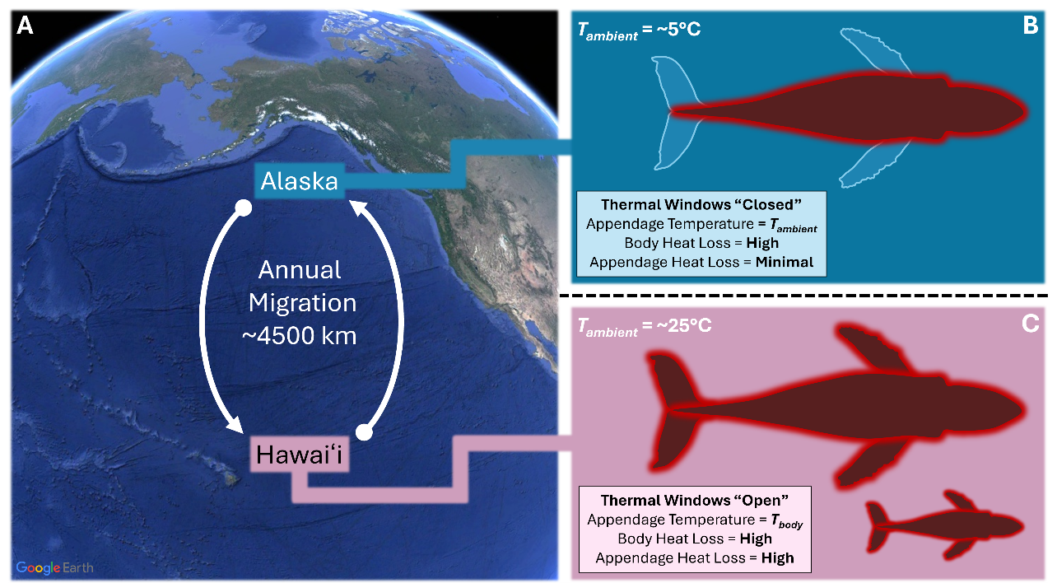
Figure 1: Schematic showing the relationship between geographic location and anatomical heat loss dynamics. A) Map of the North Pacific showing the migratory route for humpback whales between Alaska and Hawai‘i. B) the heat loss dynamics for a hypothetical animal in Alaska with thermal windows (i.e., pectoral fins and tail flukes) closed. C) Similar heat loss dynamics for an animal in Hawai‘i with thermal windows open and a calf present. Map image sourced from Google Earth version 7.3.6.10441.

Figure 2: Relationships between body length and potential daily conductive heat loss from A) the flippers, B) the flukes, and C) the body. Data points for the flippers and flukes assume an open thermal state. Points denote median values for each individual, with lines extending along the CI from 5% to 95%, based on our individual-scale Monte Carlo simulations. Dashed and dotted lines denote the regressions for those median and confidence interval values, respectively.
Figure 3: Relationship between body length and potential daily whole-animal heat loss for animals in Alaska (blue) with their thermal windows closed, and for animals in Hawai‘i (pink) with their thermal windows open. Points denote median values for each individual, with lines extending along the CI from 5% to 95%, based on our individual-scale Monte Carlo simulations. Dashed and dotted lines denote the regressions for those median and confidence interval values, respectively.
Figure 4: Relationship between body condition and mass-specific heat loss potential (MJ day⁻¹ kJ⁻¹) with thermal windows open (Hawai‘i; Pink) and closed (Alaska; Blue) for Calves (top), Adults (middle), and Lactating females (bottom). Dotted vertical lines denote the median value for each set of points.
Figure 5: Relationship between body length and lower critical temperature for calves, assuming metabolic heat production values of 1-2x Kleiber BMR (in descending order). Horizontal dotted lines denote the temperatures (°C) used for our warm (Hawai‘i) and cold (Alaska) environments. The vertical dotted line denotes the mean estimated TL at birth (4.31 m) for calves in our dataset.
Figure 6: Relationship between body length and the range of potential heat loss values for both Alaska (blue) and Hawai‘i (pink), displayed as multiples of “Kleiber” BMR (with the horizontal dashed line denoting 1x Kleiber BMR). The top and bottom of each range correspond to the potential heat loss with thermal windows open and closed, respectively. The darker purple portion is the overlap between the two ranges. Gray points denote median field metabolic rate estimates (derived from our breathing frequency regression) for each individual, with lines extending along the CI from 5% to 95%.
Figure 7: Age vs. the minimum sustainable metabolic rate for calves in Alaska (blue) and Hawai‘i (pink), displayed both as A) multiples of Kleiber BMR or B) absolute wattage. The horizontal dashed line denotes 1x Kleiber BMR, while the vertical dotted line corresponds to 90 days. The area of the shaded region has been calculated to show the cost differences for a calf growing in Hawai‘i vs. Alaska and maintaining its lowest sustainable metabolic rate.

Supplemental Materials
ID | Species | Sex | Age class | Stranding notes | Flipper / fluke | Body length (m) | Appendage blubber thickness (mm)
FA-6436 | pygmy killer | Male | Subadult |  | Flipper | 2.13 | 0.70
FA-9529 | pygmy killer | Female | Subadult |  | Flipper | 2.20 | 0.80
FA-9519 | pygmy killer | Female | Adult | Pregnant | Flipper | 2.29 | 1.70
FA-6599 | pygmy killer | Female | Adult | Lactating | Flipper | 2.32 | 3.50
FA-8456 | pygmy killer | Male | Calf |  | Flipper | 1.37 | 1.30
FA-2937 | pygmy killer | Male | Adult | Emaciated | Flipper | 2.32 | 0.80
FA-7995 | pygmy killer | Male | Adult | Emaciated | Flipper | 2.35 | 1.80
SC-3576 | striped dolphin | Male | Adult |  | Flipper/Fluke | 2.11 | 2.05
C-551 | humpback whale | Unknown | Juvenile |  | Fluke | 9.26 | 8.27
FEF-Plasticized | humpback whale | Male | Subadult |  | Flipper | 9.02 | 3.00
HP2015001 | harbor porpoise | Unknown | Unknown |  | Fluke | 1.47 | 0.47

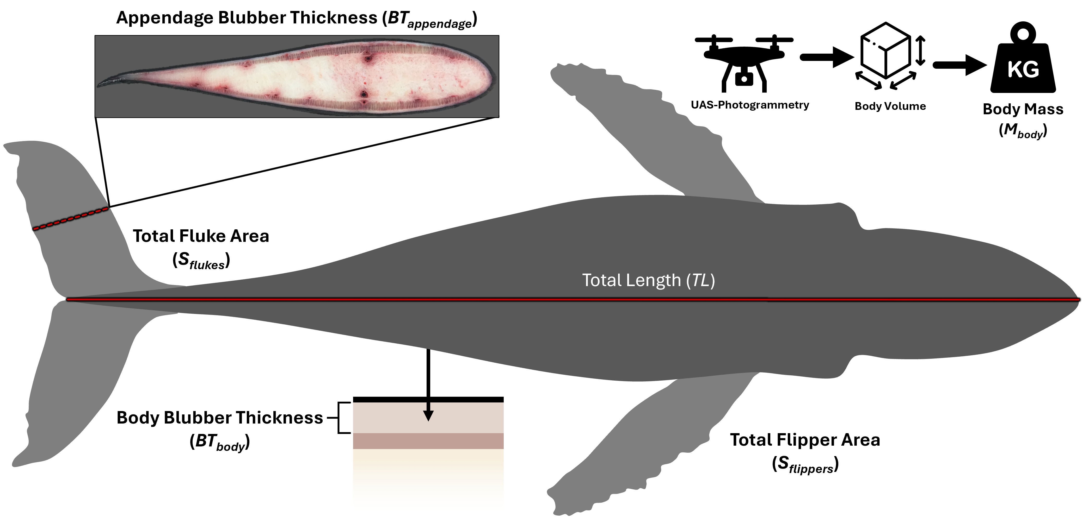
Figure S1: Schematic showing various morphometric and model-critical variables were measured. The cross-section (top left) is from the fluke of a harbor porpoise (C-489), showing the internal layers and vasculature, as well as the fusiform shape.
Figure S2: Morphometric relationships between body length and surface area estimates for A) the body, B) the flippers, and C) the flukes. Body values are taken from our broader dataset, while extremity values are taken from our subset of UAS data with clear flippers and flukes at the surface. Density plots show the residuals for each relationship (D-F), with the blue and red dotted lines denoting the 5% and 95% CI of each dataset, respectively.
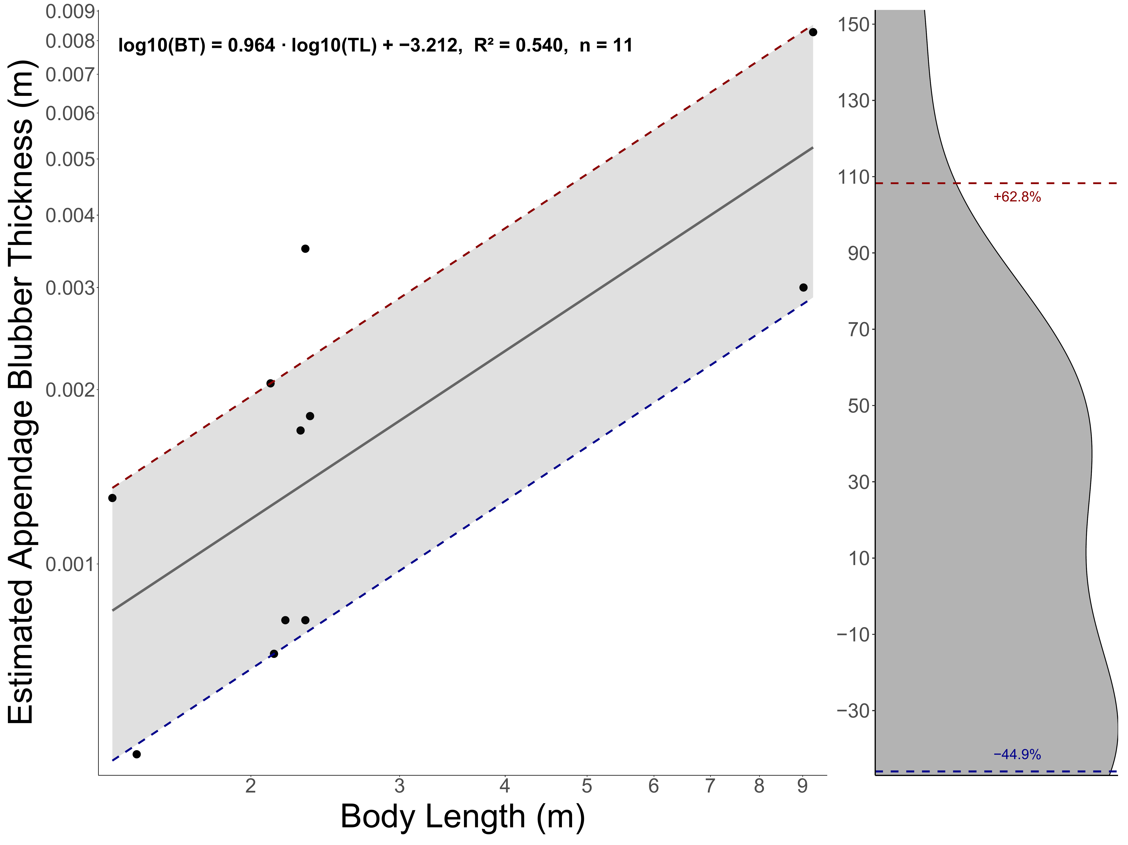
Figure S3: Morphometric relationships between body length and estimated appendage blubber thickness taken from our stranded animal dataset. Density plots show the residuals for each relationship (D-F), with the blue and red dotted lines denoting the 10% and 90% CI of each dataset, respectively.
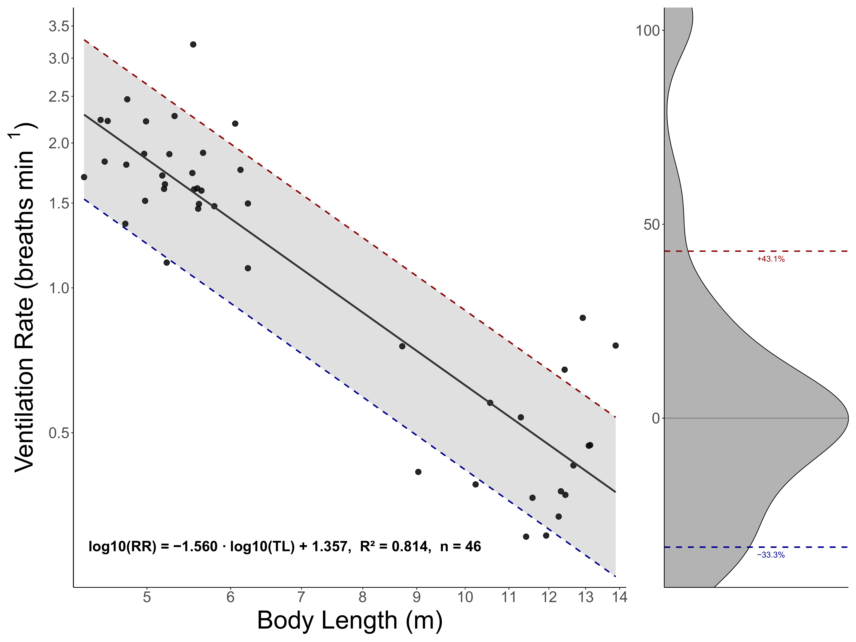
Figure S4: Log-transformed regression between body length and ventilation rate, taken from CATS tag data. The density plot shows the residuals for each individual, with the blue and red dotted lines denoting the 10% and 90% CI of each dataset, respectively.
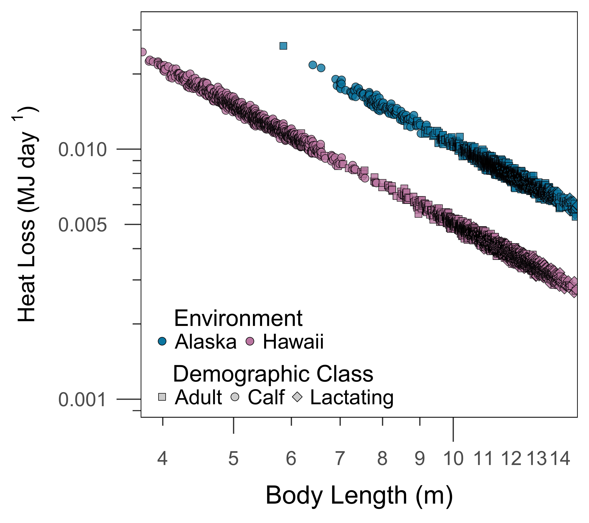
Figure S5: Ventilatory heat loss in Alaska (blue) and Hawai‘i (pink).

References
Adamczak, S. K., Pabst, D. A., McLellan, W. A. and Thorne, L. H. (2020). Do bigger bodies require bigger radiators? Insights into thermal ecology from closely related marine mammal species and implications for ecogeographic rules. Journal of Biogeography 47, 1193–1206.
Alexander, R. M. (2005). Models and the scaling of energy costs for locomotion. J. Exp. Biol. 208, 1645–1652.
Allen, A. S., Read, A. J., Shorter, K. A., Gabaldon, J., Blawas, A. M., Rocho-Levine, J. and Fahlman, A. (2022). Dynamic body acceleration as a proxy to predict the cost of locomotion in bottlenose dolphins. J. Exp. Biol. 225, jeb243121.
Armstrong, D. G. and Blaxter, K. L. (1956). Heat Increments of Feeding in Ruminants. Nature 177, 1183–1184.
Bejder, L., Videsen, S., Hermannsen, L., Simon, M., Hanf, D. and Madsen, P. T. (2019). Low energy expenditure and resting behaviour of humpback whale mother-calf pairs highlights conservation importance of sheltered breeding areas. Sci. Rep. 9, 771.
Bell, G. (1980). The Costs of Reproduction and Their Consequences. The American Naturalist 116, 45–76.
Benarroch, E. E. (2007). Thermoregulation: Recent concepts and remaining questions. Neurology 69, 1293–1297.
Blawas, A. M. (2025). respdetect: A Matlab tool for detecting breath events from whale biologger data. Journal of Open Source Software 10, 7858.
Bolnick, D. I. and Ferry-Graham, L. A. (2002). Optimizing prey-capture behaviour to maximize expected net benefit. Evol Ecol Res 4, 843–855.
Boyles, J. G. and Brack, V., Jr. (2009). Modeling Survival Rates of Hibernating Mammals with Individual-Based Models of Energy Expenditure. Journal of Mammalogy 90, 9–16.
Castellote, M., Clark, C. W. and Lammers, M. O. (2012). Acoustic and behavioural changes by fin whales (Balaenoptera physalus) in response to shipping and airgun noise. Biological Conservation 147, 115–122.
Christiansen, F., Sironi, M., Moore, M. J., Martino, M. D., Ricciardi, M., Warick, H. A., Irschick, D. J., Gutierrez, R. and Uhart, M. M. (2019). Estimating body mass of free-living whales using aerial photogrammetry and 3D volumetrics. Methods in Ecology and Evolution 10, 2034–2044.
Christiansen, F., Bejder, L., Burnell, S., Ward, R. and Charlton, C. (2022). Estimating the cost of growth in southern right whales from drone photogrammetry data and long-term sighting histories. Mar. Ecol. Prog. Ser. 687, 173–194.
Christiansen, F., Sprogis, K. R., Nielsen, M. L. K., Glarou, M. and Bejder, L. (2023). Energy expenditure of southern right whales varies with body size, reproductive state and activity level. J. Exp. Biol. 226, jeb.245137.
Christiansen, F., Madsen, P. T., Andrews-Goff, V., Double, M. C., How, J. R., Clapham, P., Ivashchenko, Y., Tormosov, D. and Sprogis, K. R. (2025). Extreme capital breeding for giants: Effects of body size on humpback whale energy expenditure and fasting endurance. Ecological Modelling 501, 110994.
Christiansen, F., Sironi, M., Lewin, N., Marón, C. F. and Uhart, M. M. (2026). Influence of water temperature, body size, condition and gull-inflicted lesions on heat loss in southern right whales in Península Valdés, Argentina. J Exp Biol 229, jeb250925.
Clapham, P. (2001). Why do Baleen Whales Migrate? Mar. Mammal Sci. 17, 432–436.
Corkeron, P. J. and Connor, R. C. (1999). Why Do Baleen Whales Migrate? Mar. Mammal Sci. 15, 1228–1245.
Curé, C., Antunes, R., Alves, A., Visser, F., Kvadsheim, P. H. and Miller, P. J. O. (2013). Responses of male sperm whales (Physeter macrocephalus) to killer whale sounds: implications for anti-predator strategies. Scientific Reports 3, 1579–1579.
Curé, C., Sivle, L. D., Visser, F., Wensveen, P. J., Isojunno, S., Harris, C. M., Kvadsheim, P. H., Lam, F.-P. A. and Miller, P. J. O. (2015). Predator sound playbacks reveal strong avoidance responses in a fight strategist baleen whale. Mar. Ecol. Prog. Ser. 526, 267–282.
Czapanskiy, M. F., Savoca, M. S., Gough, W. T., Segre, P. S., Wisniewska, D. M., Cade, D. E. and Goldbogen, J. A. (2021). Modelling short-term energetic costs of sonar disturbance to cetaceans using high-resolution foraging data. Journal of Applied Ecology 58, 1643–1657.
Deser, C., Alexander, M. A., Xie, S.-P. and Phillips, A. S. (2010). Sea Surface Temperature Variability: Patterns and Mechanisms. Annu. Rev. Mar. Sci. 2, 115–143.
Fahlman, A., Loring, S. H., Ferrigno, M., Moore, C., Early, G., Niemeyer, M., Lentell, B., Wenzel, F., Joy, R. and Moore, M. J. (2011). Static inflation and deflation pressure–volume curves from excised lungs of marine mammals. J. Exp. Biol. 214, 3822.
Fahlman, A., van der Hoop, J., Moore, M. J., Levine, G., Rocho-Levine, J. and Brodsky, M. (2016). Estimating energetics in cetaceans from respiratory frequency: why we need to understand physiology. Biology Open 5, 436–442.
Fahlman, A., Schorr, G. S., Sweeney, D. A., Rone, B. K., Coates, S. N., Allen, A. S., Martín López, L. M., Jarvis, S. M. and Falcone, E. A. (2025). Modelling the effect of varying metabolic rate and cardiac output on estimated tissue and blood O2 and CO2 levels in an extreme deep-diver, the goose-beaked whale (Ziphius cavirostris). Experimental Physiology n/a,.
Favilla, A. B. and Costa, D. P. (2020). Thermoregulatory Strategies of Diving Air-Breathing Marine Vertebrates: A Review. Front. Ecol. Evol. 8,.
Favilla, A. B., Adamczak, S. K. and Costa, D. P. (2024). Thermoregulation. In The Physiology of Dolphins, pp. 29–47. Elsevier.
Felts, W. J. L. (2023). 14. Some Functional and Structural Characteristics of Cetacean Flippers and Flukes. In Whales, Dolphins, and Porpoises (ed. Norris, K. S.), pp. 255–276. University of California Press.
Fish, F. E. and Battle, J. M. (1995). Hydrodynamic design of the humpback whale flipper. J. Morph. 225, 51–60.
Fish, F. E. and Lauder, G. V. (2006). Passive and active flow control by swimming fishes and mammals. Annual Review of Fluid Mechanics 38, 193–224.
Folkow, L. P. and Blix, A. S. (1992). Metabolic rates of minke whales (Balaenoptera acutorostrata) in cold water. Acta Physiologica Scandinavica 146, 141–150.
Ford, T. J., Werth, A. J. and George, J. C. (2013). An intraoral thermoregulatory organ in the bowhead whale (Balaena mysticetus), the corpus cavernosum maxillaris. Anat Rec (Hoboken) 296, 701–708.
Gavazzi, L. M., Nair, M., Suydam, R., Usip, S., Thewissen, J. G. M. and Cooper, L. N. (2024). Protein signaling and morphological development of the tail fluke in the embryonic beluga whale (Delphinapterus leucas). Dev Dyn 253, 859–874.
George, J. C. (2009). Growth, morphology and energetics of bowhead whales (Balaena mysticetus).
George, J. C., Horstmann, L., Fortune, S., Sformo, T. L., Elsner, R. and Follmann, E. (2021). Thermoregulation and energetics. In The Bowhead Whale, pp. 237–260. Elsevier.
Glarou, M., Rasmussen, M. H., Poldner, A., Ruppert, S. N. S., Sotiropoulou, D., Sadozai, Z., Jarzynowska, M., Iversen, M. R., Sigurðsson, G. M., Halldórsson, S. D., et al. (2025a). Size-specific strategies of sympatric cetaceans to reduce heat loss. J Exp Biol 228, jeb249356.
Glarou, M., Christiansen, F., Iwata, T., Basran, C. J., Ruppert, S. N. S., Sotiropoulou, D., Iversen, M. R., Akamatsu, T., Schnitzler, J. G., Siebert, U., et al. (2025b). Respiration rates and inferred mass-specific field metabolic rates decline with body size among five sympatric cetaceans. J Comp Physiol B 195, 659–675.
Goldbogen, J. A., Cade, D. E., Wisniewska, D. M., Potvin, J., Segre, P. S., Savoca, M. S., Hazen, E. L., Czapanskiy, M. F., Kahane-Rapport, S. R., DeRuiter, S. L., et al. (2019a). Why whales are big but not bigger: Physiological drivers and ecological limits in the age of ocean giants. Science 366, 1367–1372.
Goldbogen, J. A., Cade, D. E., Calambokidis, J., Czapanskiy, M. F., Fahlbusch, J. A., Friedlaender, A. S., Gough, W. T., Kahane-Rapport, S. R., Savoca, M. S., Ponganis, K. V., et al. (2019b). Extreme bradycardia and tachycardia in the world’s largest animal. PNAS 116, 25329–25332.
Gough, W. T., Fish, F. E., Wainwright, D. K. and Bart-Smith, H. (2018). Morphology of the core fibrous layer of the cetacean tail fluke. J. Morph. 279, 757–765.
Gough, W. T., Cade, D. E., Czapanskiy, M. F., Potvin, J., Fish, F. E., Kahane-Rapport, S. R., Savoca, M. S., Bierlich, K. C., Johnston, D. W., Friedlaender, A. S., et al. (2022). Fast and Furious: Energetic Tradeoffs and Scaling of High-Speed Foraging in Rorqual Whales. Integr. Org. Biol. 4, obac038.
Gough, W. T., Madrigal, B. C., Hollers, A., Currie, J. J., Baird, R. W., West, K. L., Fahlman, A., Fish, F. E., Evans, L., van Aswegen, M., et al. (2025). Daily energetic expenditure and energy consumption of short-finned pilot whales. J.Exp. Biol.
Griffiths, D. (1980). Foraging Costs and Relative Prey Size. The American Naturalist 116, 743–752.
He, R. S., De Ruiter, S., Westover, T., Somarelli, J. A., Blawas, A. M., Dayanidhi, D. L., Singh, A., Steves, B., Driesinga, S., Halsey, L. G., et al. (2023). Allometric scaling of metabolic rate and cardiorespiratory variables in aquatic and terrestrial mammals. Physiological Reports 11, e15698.
Heyning, J. E. and Mead, J. G. (1997). Thermoregulation in the Mouths of Feeding Gray Whales. Science 278, 1138–1140.
Hin, V., Harwood, J. and de Roos, A. M. (2019). Bio-energetic modeling of medium-sized cetaceans shows high sensitivity to disturbance in seasons of low resource supply. Ecological Applications 29, e01903.
Hohn, A. A., Read, A. J., Fernandez, S., Vidal, O. and Findley, L. T. (1996). Life history of the vaquita, Phocoena sinus (Phocoenidae, Cetacea). Journal of Zoology 239, 235–251.
Hokkanen, J. E. I. (1990). Temperature regulation of marine mammals. Journal of Theoretical Biology 145, 465–485.
Innes, S., Lavigne, D. M., Earle, W. M. and Kovacs, K. M. (1987). Feeding Rates of Seals and Whales. Journal of Animal Ecology 56, 115–130.
Isojunno, S., Aoki, K., Curé, C., Kvadsheim, P. H. and Miller, P. J. O. (2018). Breathing Patterns Indicate Cost of Exercise During Diving and Response to Experimental Sound Exposures in Long-Finned Pilot Whales. Front Physiol 9, 1462.
Kagawa-Viviani, A. K. and Giambelluca, T. W. (2020). Spatial Patterns and Trends in Surface Air Temperatures and Implied Changes in Atmospheric Moisture Across the Hawaiian Islands, 1905–2017. Journal of Geophysical Research: Atmospheres 125, e2019JD031571.
Kahane‐Rapport, S. R. and Goldbogen, J. A. (2018). Allometric scaling of morphology and engulfment capacity in rorqual whales. J. Morph. 279, 1256–1268.
Kanwisher, J. and Sundnes, G. (1966). 18. Thermal Regulation in Cetaceans. In Whales, Dolphins, and Porpoises (ed. Norris, K. S.), pp. 397–409. University of California Press.
Kettemer, L. E., Rikardsen, A. H., Biuw, M., Broms, F., Mul, E. and Blanchet, M.-A. (2022). Round-trip migration and energy budget of a breeding female humpback whale in the Northeast Atlantic. PLOS ONE 17, e0268355.
Kleiber, M. (1975). Metabolic turnover rate: A physiological meaning of the metabolic rate per unit body weight. Journal of Theoretical Biology 53, 199–204.
Kooyman, G. L. (1973). Respiratory Adaptations in Marine Mammals. American Zoologist 13, 457–468.
Kshatriya, M. and Blake, R. W. (1988). Theoretical model of migration energetics in the blue whale, Balaenoptera musculus. Journal of Theoretical Biology 133, 479–498.
Kvadsheim, P. h. and Folkow, L. p. (1997). Blubber and flipper heat transfer in harp seals. Acta Physiologica Scandinavica 161, 385–395.
Lavigne, D. M., Innes, S., Worthy, G. A. J. and Kovacs, K. M. (1986). Metabolic rate—Body size relations in marine mammals. Journal of Theoretical Biology 122, 123–124.
LindstrÖM, Å., Klaassen, M. and Kvist, A. (1999). Variation in energy intake and basal metabolic rate of a bird migrating in a wind tunnel. Funct. Ecol. 13, 352–359.
Lockyer, C. (1976). Body weights of some species of large whales. ICES Journal of Marine Science 36, 259–273.
Lockyer, C. (1981). Growth and energy budgets of large baleen whales from the Southern Hemisphere.
Lockyer, C. (1987). The relationship between body fat, food resource and reproductive energy costs in North Atlantic fin whales (Balaenoptera physalus). Symp. Zool. Soc. Lond. 57, 343–361.
McNab, B. K. (1988). Complications Inherent in Scaling the Basal Rate of Metabolism in Mammals. The Quarterly Review of Biology 63, 25–54.
Meagher, E. M., McLellan, W. A., Westgate, A. J., Wells, R. S., Blum, J. E. and Pabst, D. A. (2008). Seasonal patterns of heat loss in wild bottlenose dolphins (Tursiops truncatus). J Comp Physiol B 178, 529–543.
Mehta, A. V., Allen, J. M., Constantine, R., Garrigue, C., Jann, B., Jenner, C., Marx, M. K., Matkin, C. O., Mattila, D. K., Minton, G., et al. (2007). Baleen whales are not important as prey for killer whales Orcinus orca in high-latitude regions. Mar. Ecol. Prog. Ser. 348, 297–307.
Miller, C. A., Reeb, D., Best, P. B., Knowlton, A. R., Brown, M. W. and Moore, M. J. (2011). Blubber thickness in right whales Eubalaena glacialis and Eubalaena australis related with reproduction, life history status and prey abundance. Marine Ecology Progress Series 438, 267–283.
Millward, D. J., Garlick, P. J. and Reeds, P. J. (1976). The energy cost of growth. Proceedings of the Nutrition Society 35, 339–349.
Modest, M., Irvine, L., Andrews-Goff, V., Gough, W., Johnston, D., Nowacek, D., Pallin, L., Read, A., Moore, R. T. and Friedlaender, A. (2021). First description of migratory behavior of humpback whales from an Antarctic feeding ground to a tropical calving ground. Anim. Biotelemetry 9, 42.
Nemeth, C., Gough, W. T., Segre, P. S., Fish, F. E., Szabo, A., Fassmann, W. N., Thomson, S. L., van Aswegen, M., Burrows, J. A., Chenoweth, E. M., et al. (2025). The key to bubble-net feeding: how humpback whale morphology functionally differs from other baleen whales. J Exp Biol 228, jeb249607.
Noren, S. R. and Rosen, D. A. S. (2023). What are the Metabolic Rates of Marine Mammals and What Factors Impact this Value: A review. Conservation Physiology 11, coad077.
Parry, D. A. (1949). The swimming of whales and a discussion of Gray’s paradox. J. Exp. Biol. 26, 24–28.
Pirotta, E., Mangel, M., Costa, D. P., Mate, B., Goldbogen, J. A., Palacios, D. M., Hückstädt, L. A., McHuron, E. A., Schwarz, L. and New, L. (2018). A Dynamic State Model of Migratory Behavior and Physiology to Assess the Consequences of Environmental Variation and Anthropogenic Disturbance on Marine Vertebrates. The American Naturalist 191, E40–E56.
Pitman, R. L., Durban, J. W., Joyce, T., Fearnbach, H., Panigada, S. and Lauriano, G. (2020). Skin in the game: Epidermal molt as a driver of long-distance migration in whales. Marine Mammal Science 36, 565–594.
Ray, C. (1960). The application of Bergmann’s and Allen’s rules to the poikilotherms. Journal of Morphology 106, 85–108.
Remick, D. (1992). Measuring the costs of reproduction. Trends in Ecology & Evolution 7, 42–45.
Rojano-Doñate, L., McDonald, B. I., Wisniewska, D. M., Johnson, M., Teilmann, J., Wahlberg, M., Højer-Kristensen, J. and Madsen, P. T. (2018). High field metabolic rates of wild harbour porpoises. Journal of Experimental Biology 221, jeb185827.
Ryg, M., Lydersen, C., Knutsen, L. Ø., Bjørge, A., Smith, T. G. and ØRitsland, N. A. (1993). Scaling of insulation in seals and whales. Journal of Zoology 230, 193–206.
Schindelin, J., Arganda-Carreras, I., Frise, E., Kaynig, V., Longair, M., Pietzsch, T., Preibisch, S., Rueden, C., Saalfeld, S., Schmid, B., et al. (2012). Fiji: an open-source platform for biological-image analysis. Nature Methods 9, 676–682.
Schmidt-Nielsen, K. (1972). Locomotion: Energy Cost of Swimming, Flying, and Running. Science, New Series 177, 222–228.
Scholander, P. F. and Schevill, W. E. (1955). Counter-Current Vascular Heat Exchange in the Fins of Whales. Journal of Applied Physiology 8, 279–282.
Scholander, P. F., Hock, R., Walters, V., Johnson, F. and Irving, L. (1950). Heat Regulation in Some Arctic and Tropical Mammals and Birds. Biological Bulletin 99, 237–258.
Segre, P. S., Potvin, J., Cade, D. E., Calambokidis, J., Di Clemente, J., Fish, F. E., Friedlaender, A. S., Gough, W. T., Kahane-Rapport, S. R., Oliveira, C., et al. (2020). Energetic and physical limitations on the breaching performance of large whales. eLife 9,.
Southall, B. L., Nowacek, D. P., Miller, P. J. O. and Tyack, P. L. (2016). Experimental field studies to measure behavioral responses of cetaceans to sonar. Endangered Species Research 31, 293–315.
Spaargaren, D. H. (1994). Metabolic rate and body size: a new view on the “surface law” for basic metabolic rate. Acta Biotheor. 42,.
Sumich, J. L. (2021). Why Baja? A bioenergetic model for comparing metabolic rates and thermoregulatory costs of gray whale calves (Eschrichtius robustus). Marine Mammal Science 37, 870–887.
Sun, Q., Morikawa, H., Kobayashi, S., Ueda, K., Miyahara, H. and Nakashima, M. (2010). Structure and Mechanical Properties on Tail Flukes of Dolphin. J. Abmech 1, 45–50.
Szabo, A., Bejder, L., Warick, H., van Aswegen, M., Friedlaender, A. S., Goldbogen, J., Kendall-Bar, J. M., Leunissen, E. M., Angot, M. and Gough, W. T. (2024). Solitary humpback whales manufacture bubble-nets as tools to increase prey intake. Royal Society Open Science 11, 240328.
Torres-Romero, E. J., Morales-Castilla, I. and Olalla-Tárraga, M. Á. (2016). Bergmann’s rule in the oceans? Temperature strongly correlates with global interspecific patterns of body size in marine mammals. Global Ecology and Biogeography 25, 1206–1215.
Tyack, P. and Whitehead, H. (1982). Male Competition in Large Groups of Wintering Humpback Whales. Behaviour 83, 132–154.
van Aswegen, M., Christiansen, F., Symons, J., Mann, J., Nicholson, K., Sprogis, K. and Bejder, L. (2019). Morphological differences between coastal bottlenose dolphin (Tursiops aduncus) populations identified using non-invasive stereo-laser photogrammetry. Sci Rep 9, 12235.
van Aswegen, M., Szabo, A., Currie, J. J., Stack, S. H., West, K. L., Hofmann, N., Christiansen, F. and Bejder, L. (2025b). Energetic cost of gestation and prenatal growth in humpback whales. J. Physiol n/a,.
van Aswegen, M., Szabo, A., Currie, J. J., Stack, S. H., Evans, L., Straley, J., Neilson, J., Gabriele, C., Cates, K., Steel, D., et al. (2025a). Maternal investment, body condition and calf growth in humpback whales. J. Physiol.
van Aswegen, M., Szabo, A., Currie, J., Stack, S., Straley, J., Neilson, J., Gabriele, C., Cates, K., Baker, C., Steel, D., et al. (2025c). Age-specific body length, mass, and energetic cost of growth in humpback whales. Marine Ecology Progress Series 770, 171–194.
Videsen, S. K. A., Simon, M., Christiansen, F., Friedlaender, A., Goldbogen, J., Malte, H., Segre, P., Wang, T., Johnson, M. and Madsen, P. T. (2023). Cheap gulp foraging of a giga-predator enables efficient exploitation of sparse prey. Sci. Adv. 9, eade3889.
Víkingsson, G. (1990). Energetic studies on Fin and Sei whales caught off Iceland. Rep. int Whal. Commn 40, 365–373.
Wahrenbrock, E. A., Maruschak, G. F., Elsner, R. and Kenney, D. W. (1974). Respiration and Metabolism in Two Baleen Whale Calves. Mar. Fish. Rev. 36, 3–9.
Watts, P., Hansen, S. and Lavigne, D. M. (1993). Models of Heat Loss by Marine Mammals: Thermoregulation Below the Zone of Irrelevance. Journal of Theoretical Biology 163, 505–525.
White, C. R. (2010). There is no single p. Nature 464, 691–693.
Williams, T. M. (2022). Racing Time: Physiological Rates and Metabolic Scaling in Marine Mammals. Integr Comp Biol 62, 1439–1447.
Williams, T. M. and Davis, R. W. (2024). Energetic costs of rest and locomotion in dolphins. In The Physiology of Dolphins (ed. Fahlman, A.) and Hooker, S. K.), pp. 9–28. Academic Press.
Williams, T. M., Noren, D., Berry, P., Estes, J. A., Allison, C. and Kirtland, J. (1999). The diving physiology of bottlenose dolphins (Tursiops truncatus): III. Thermoregulation at depth. Journal of Experimental Biology 202, 2763–2769.
Wood, S. N. (2011). Fast Stable Restricted Maximum Likelihood and Marginal Likelihood Estimation of Semiparametric Generalized Linear Models. J. R. Stat. Soc. Ser. B. Stat. Methodol. 73, 3–36.
Woodward, B. L., Winn, J. P. and Fish, F. E. (2006). Morphological specializations of baleen whales associated with hydrodynamic performance and ecological niche. J. Morph. 267, 1284–1294.
Zerbini, A. N., Andriolo, A., Heide-Jørgensen, M. P., Pizzorno, J. L., Maia, Y. G., VanBlaricom, G. R., DeMaster, D. P., Simões-Lopes, P. C., Moreira, S. and Bethlem, C. (2006). Satellite-monitored movements of humpback whales Megaptera novaeangliae in the Southwest Atlantic Ocean. Mar. Ecol. Prog. Ser. 313, 295–304.

